What is the Process of Mobile App Development from Idea to Launch?
Focus Keyword: Mobile App Development
Meta Title: Step-by-Step Mobile App Development Process from Idea to Launch
Meta Description: Discover the complete mobile app development process from idea to launch, including planning, design, development, testing, and app store deployment.
Feature Image:
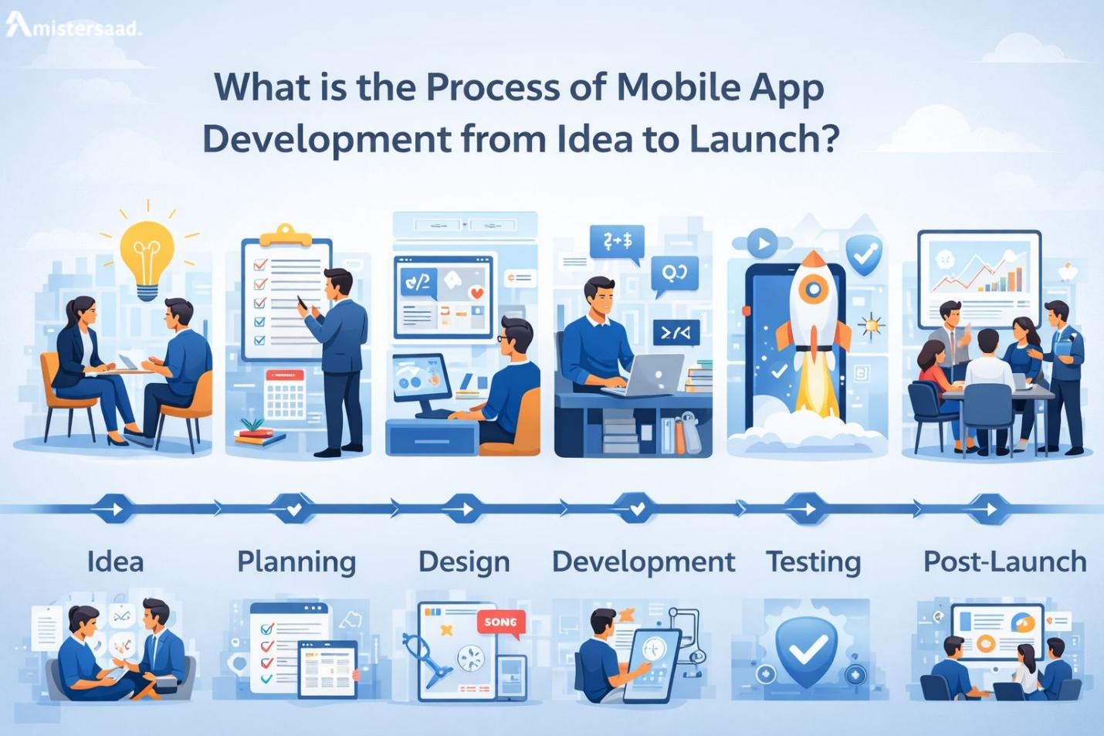
Introduction
Every successful app begins with a clear idea and a strong plan. Understanding the full development journey helps companies make better decisions. The process shapes how the app functions, how users interact and how the app performs in the market. Many brands seek reliable teams to build apps that support growth and meet customer needs. The journey involves research, planning, design, development, testing and launch. Each stage holds its own importance. Teams follow a structured workflow to keep progress smooth. Businesses aim for better performance and long term stability. Many brands explore Mobile Application Development Dubai for expert support. This article explains the complete journey from idea to launch in simple and clear steps.

Initial Research and Goal Definition
Every app begins with strong research. Teams study the market and understand user needs. They identify market gaps and target audiences. They also define clear goals for the app. Research lays the base for every decision. Teams explore trends and competitor products. They also check technical needs and market expectations. A clear vision helps avoid confusion later. Teams plan features based on real user problems.

Understanding the App Development Lifecycle
The development journey follows a structured path known as the lifecycle. This path guides teams from planning to release. The App development lifecycle Dubai supports companies across every stage. Each stage builds on the previous stage. The lifecycle helps maintain quality at every level. It also reduces errors and delays in the project. Teams follow the lifecycle to achieve stable app results.
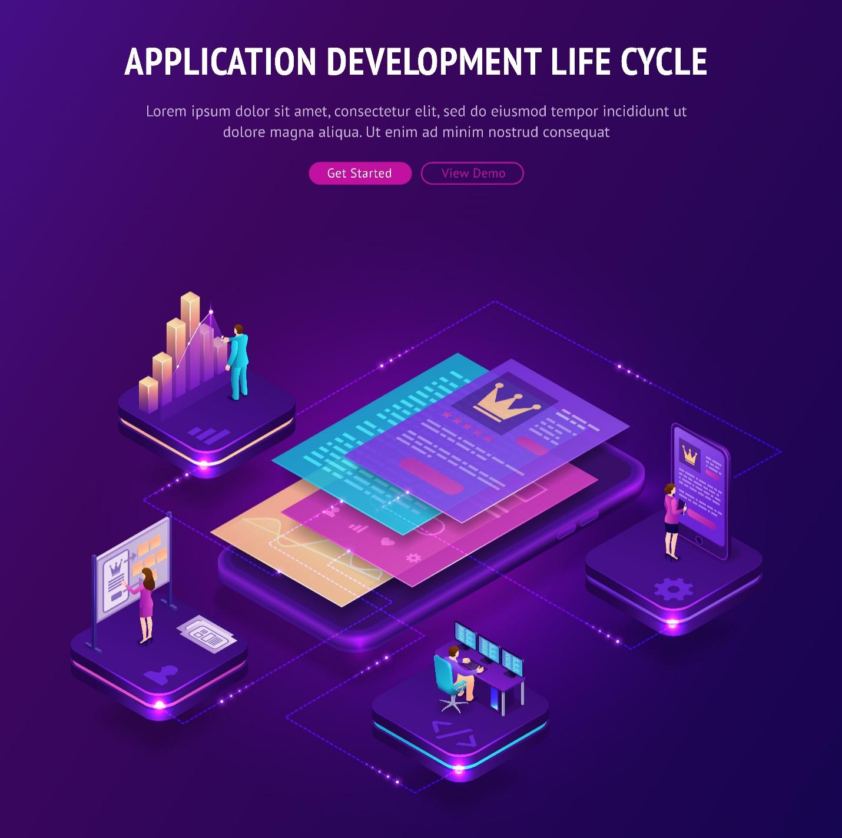

Planning the Complete App Structure
Planning defines the structure of the app. Teams decide features, screens and user flow. They create documents that guide designers and developers. Clear planning keeps all members aligned. It also prevents confusion during development. Teams set clear timelines for each task. They also plan the resources needed for the project. Good planning improves speed and accuracy. It shapes the entire project roadmap. This step also avoids unnecessary changes later. Strong planning is a major part of successful app creation.

Designing the User Experience
Designing the app begins with understanding users. The Mobile app design process focuses on clarity and ease. Designers create layouts that guide user movement. They select colors, shapes and elements that match the brand. The goal is to build a smooth and simple experience. Every element supports better interaction. Designers make sure all screens look clear. They avoid confusion for users at all steps. Good design improves user trust and comfort.


Creating Wireframes and Prototypes
Wireframes act as the basic outline of the app. They show placements of all elements. Wireframing & prototyping apps helps teams see the structure early. Prototypes show how the app moves and behaves. Prototypes also help teams test interactions. This process helps developers understand expectations. It also helps clients see the app flow clearly. Early testing saves time later. Wireframes and prototypes reduce mistakes and improve quality. They also support faster development.

Starting the Development Stage
The development stage builds the real product. Developers write the code and build all features. They follow detailed plans and wireframes. They build each part step by step. The Software development stages guide the full process. Developers work in organized cycles. Each cycle brings new features to life. This structured approach reduces errors. It helps teams track progress with clarity. The app grows stronger with each development cycle.


Following a Clear Development Workflow
A structured workflow helps teams stay organized. It keeps every task on schedule. The App development workflow supports planning and execution. It defines how tasks move from one stage to another. It ensures quality checks at every step. Developers and designers follow the workflow to avoid mistakes. This improves team communication. It also keeps the project smooth and predictable.

Testing the App at Every Stage
Testing ensures the app works correctly. Teams test each feature after development. They check performance, stability and security. They also test the app on many devices. Testing reveals bugs early. It prevents problems after launch. Testers check user flow and overall experience. They ensure the app meets all goals. Complete testing improves user satisfaction. It keeps the app reliable for long term use.

Preparing the App for Deployment
Deployment includes several important steps. Teams prepare the app for stores. They check guidelines for both major platforms. They ensure the app meets quality requirements. The App deployment steps UAE support smooth release. The team uploads the app to the store. They fill store descriptions and upload screenshots. They also follow approval rules for both platforms. After approval, the app becomes ready for public users.

Launching the App Successfully
The launch introduces the app to users. Teams monitor the release carefully. They also track early feedback. Launch strategies include marketing and user communication. They plan updates based on real user responses. A good launch creates strong first impressions. It also helps the app gain early traction. Teams stay prepared to fix any early problems. Launch is the beginning of the real journey.
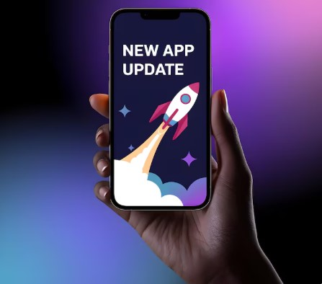

Managing Post Launch Support
Once the app is live, teams offer continuous support. Updates improve features and stability. Businesses trust Post-launch app support Dubai for reliable maintenance. Support includes bug fixes and security checks. This support keeps the app fresh and stable. Teams monitor performance based on user needs. Regular updates keep the app relevant. Post launch support improves long term value.

Role of Development Teams in Dubai
Many companies look for skilled teams for complete support. They often choose Mobile App Development Dubai for structured project handling. These teams understand market expectations. They plan each stage with strong expertise. They follow clear workflows for quality control. Their support helps businesses build long lasting apps.


Why This Process Ensures Strong Results
Following a clear process avoids confusion. Each stage strengthens the final product. Planning creates structure. Design builds user experience. Development brings the product to life. Testing ensures stability. Launch introduces the product to users. Support keeps the app growing. This process creates strong digital products.

Conclusion
The journey from idea to launch requires planning, teamwork and expertise. Each stage supports the next stage with clear structure. Strong research builds clarity. Good design improves user trust. Clean development ensures performance. Testing protects quality. Proper deployment brings the app to the public. Ongoing support keeps the product stable and secure. The full process creates long lasting digital value. Many brands follow this structure for strong app results. Businesses often trust experienced partners like Mistersaad for reliable development support. A clear development journey leads to better users, stronger performance and long term success.

FAQs
What is the first step in app development
The first step is research and goal definition.
How long does app development usually take
Development time depends on features and complexity.
Why is design important in app creation
Design improves user experience and supports smooth navigation.
Why is testing required before launch
Testing ensures stability and removes errors.
What happens after the app is launched
Teams monitor performance and release updates.
Do all apps need long term support
Yes, support keeps apps stable and secure.
